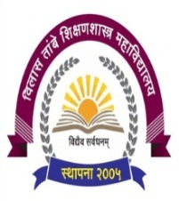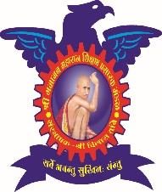

**Shri Gajanan Maharaj Shikshan Prasarak Mandal’s**

**Vilas Tambe women’s College of Education (B.ED.)**

**Dumbarwadi, Otur, Tal - Junnar, Dist - Pune - 412409**

**Links of various webinars videos organized by institute**

Our Institution, Vilas Tambe Women’s College of Education arranges some online webinars, yoga sessions on recent developments in the field of education. Here are some links of programme.

1. <https://www.youtube.com/watch?v=0oP8KbRFHoQ>
2. <https://www.youtube.com/watch?v=WfRd_lArY7Q&t=44s>
3. <https://www.youtube.com/watch?v=84mOkzBl38U&t=2218s>
4. <https://www.youtube.com/watch?v=UN0tEksO6uc>
5. https://www.youtube.com/watch?v=Uo5GXV0W1bA